Types of mobile apps

Native - Native apps are applications that are design and created for a specific device. They are installed on it and usually cannot be uninstalled. For example, one native app is Health. This is pre-installed and programmed for iOS devices. The Application is designed to track the iPhone’s movement or the Apple Watch’s movement. With modern and future technology, it will be possible to monitor much more serious conditions more accurately so that users will know how their body is doing. It also means that doctors will be able to access this data to see potential triggers such as too much movement.

[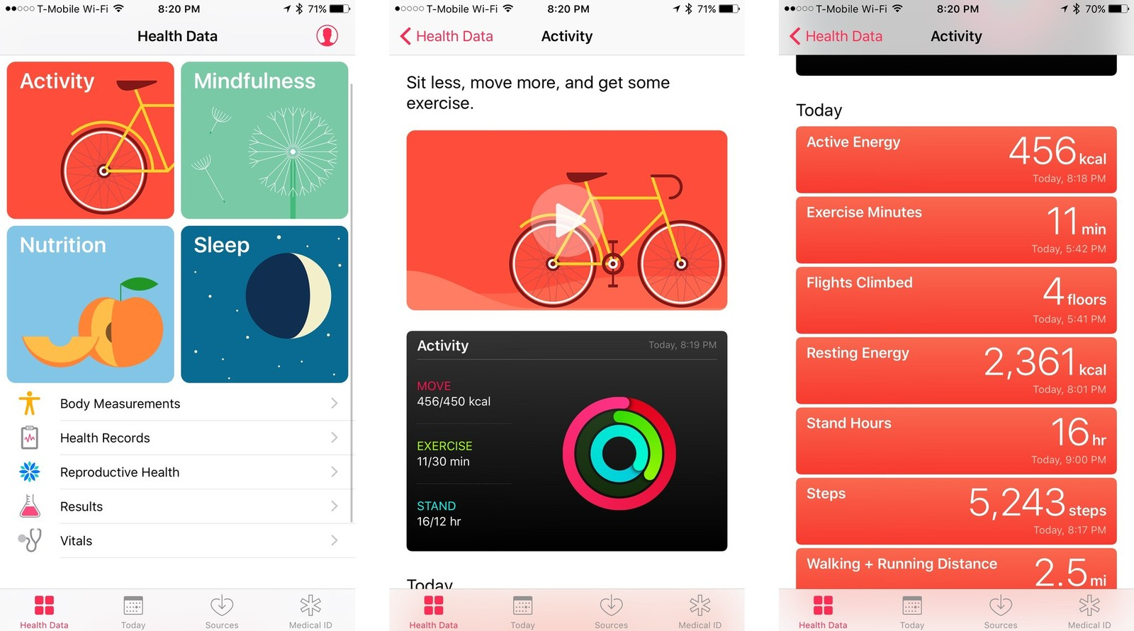[1]](https://www.imore.com/sites/imore.com/files/styles/xlarge/public/field/image/2016/09/ios-10-health-activity-1.jpg?itok=kgjNpzfq)

Web apps - Web apps are application like, however they do not need to be downloaded since the app is stored on a server and the app is accessed via a web browser. An example of a web app would be Ali Express. Ali express is a cheap goods store based in China. The web page works as normal on a computer, when used on a mobile device it is as if it is an application, however it has not been downloaded and installed.

[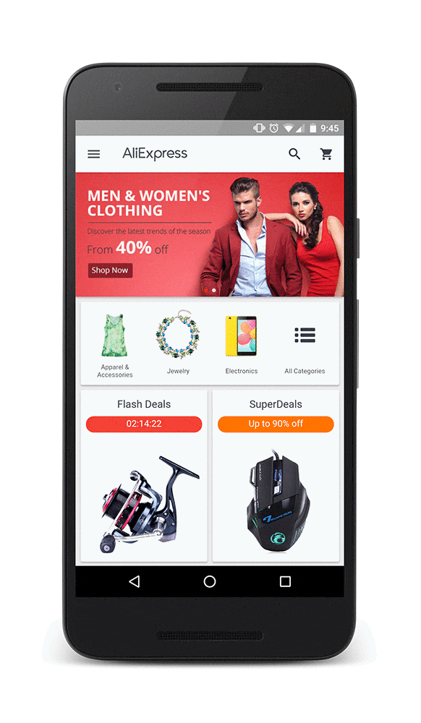[2]](https://developers.google.com/web/showcase/2016/images/aliexpress/aliexpress_framed.gif)

Hybrid - Hybrid Apps have the ability to be used on Android and iOS devices simultaneously following the same information and data on the servers. Whilst it may be programmed differently for the device, but they still access the same data. Waze is an example of a Hybrid app since it has been developed for both Android and iOS Operating Systems. The app layouts may vary slightly due to the many variables of the device such as height, width, screen size and power output, however this doesn’t mean that they are entirely different since all of the data that they gather and provide all come from the same place.

[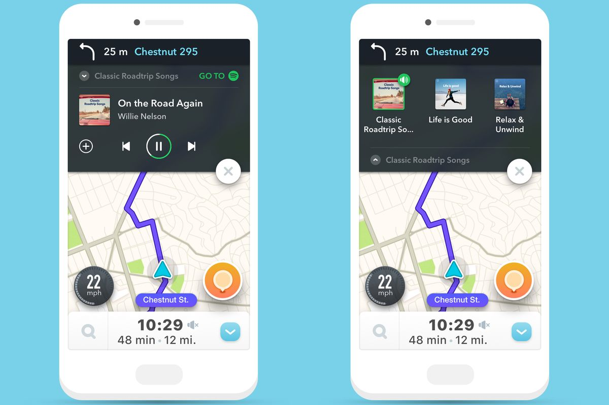](https://cdn.vox-cdn.com/thumbor/Dokf2NLzsEAILKfjR51n_P4tC0U=/0x0:2139x1536/1200x800/filters:focal(899x597:1241x939)/cdn.vox-cdn.com/uploads/chorus_image/image/53689365/waze_spotify.0.jpg)

[[3]](https://cdn.vox-cdn.com/thumbor/Dokf2NLzsEAILKfjR51n_P4tC0U=/0x0:2139x1536/1200x800/filters:focal(899x597:1241x939)/cdn.vox-cdn.com/uploads/chorus_image/image/53689365/waze_spotify.0.jpg)

Locale – Location applications are used as ways of finding locations and places of interest in any area of the world. They are important since they are much quicker than using tangible maps that only show specific area whereas a locale application allows for any area to be viewed. Due to modern technology Locale applications also allow for a special feature called ‘Street view’ where a user can view what a place would look like from on the ground. A disadvantage of this is that the images are not necessarily up to date. They don’t all match dates meaning that a place may look much difference to what it looks like on a locale application. An example of a locale application is Google Maps

[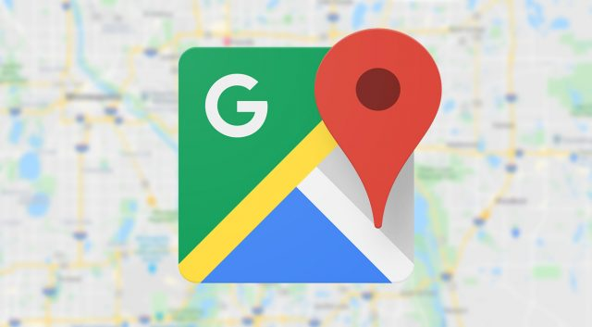[4]](https://www.extremetech.com/wp-content/uploads/2019/10/maps-generic-640x353.jpg)

Utility – Utility applications are native apps. They are designed specifically for the mobile device as they are used to change settings within the device. Depending on the make of mobile device will allow you to understand how much access to the devices settings there really are. Settings apps are not able to be uninstalled since they have major functions and properties within it that are dependent on what the user chooses for themselves. Thanks to modern technology, settings apps are allowing users to do more with their devices in terms of personalisation, for example, custom backgrounds, optional dark mode/light mode, night shift, downtime, voice activated commands, Sound effects, vibrations/haptics, view battery wellbeing and evaluate their privacy.

[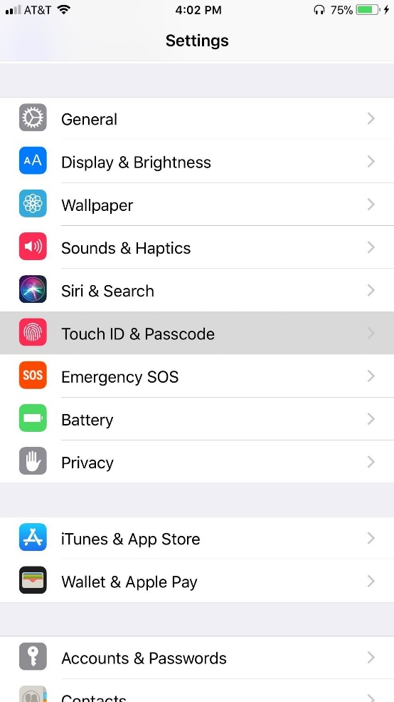[5]](https://i.stack.imgur.com/X86Wz.jpg)

Productivity – Productivity apps designed for mobile devices are becoming better all the time. They now allow users to store their work and notes in the cloud so that they can edit them on other devices. Having well designed productivity apps for mobile devices means that people will be able to work on their files using their phone instead of spending money they may not have on tablets/laptops. While productivity apps are not entirely ideal for mobile devices because of the fact that their usage is entirely inconvenient, they can still be very helpful to those who need it.

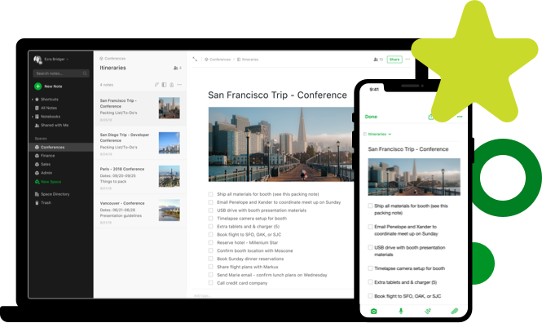[[6]](https://evernote.com/c/assets/homepage/homepage-hero-desktop.png?3044bdd28d311821)

Immersive - Fruit ninja is an immersive application that uses the full screen of the device so that the user can interact to their full intent. These applications can be downloaded on either iOS or Android. For example, Fruit ninja is an immersive application that uses the full screen of the device for the user to interact.

[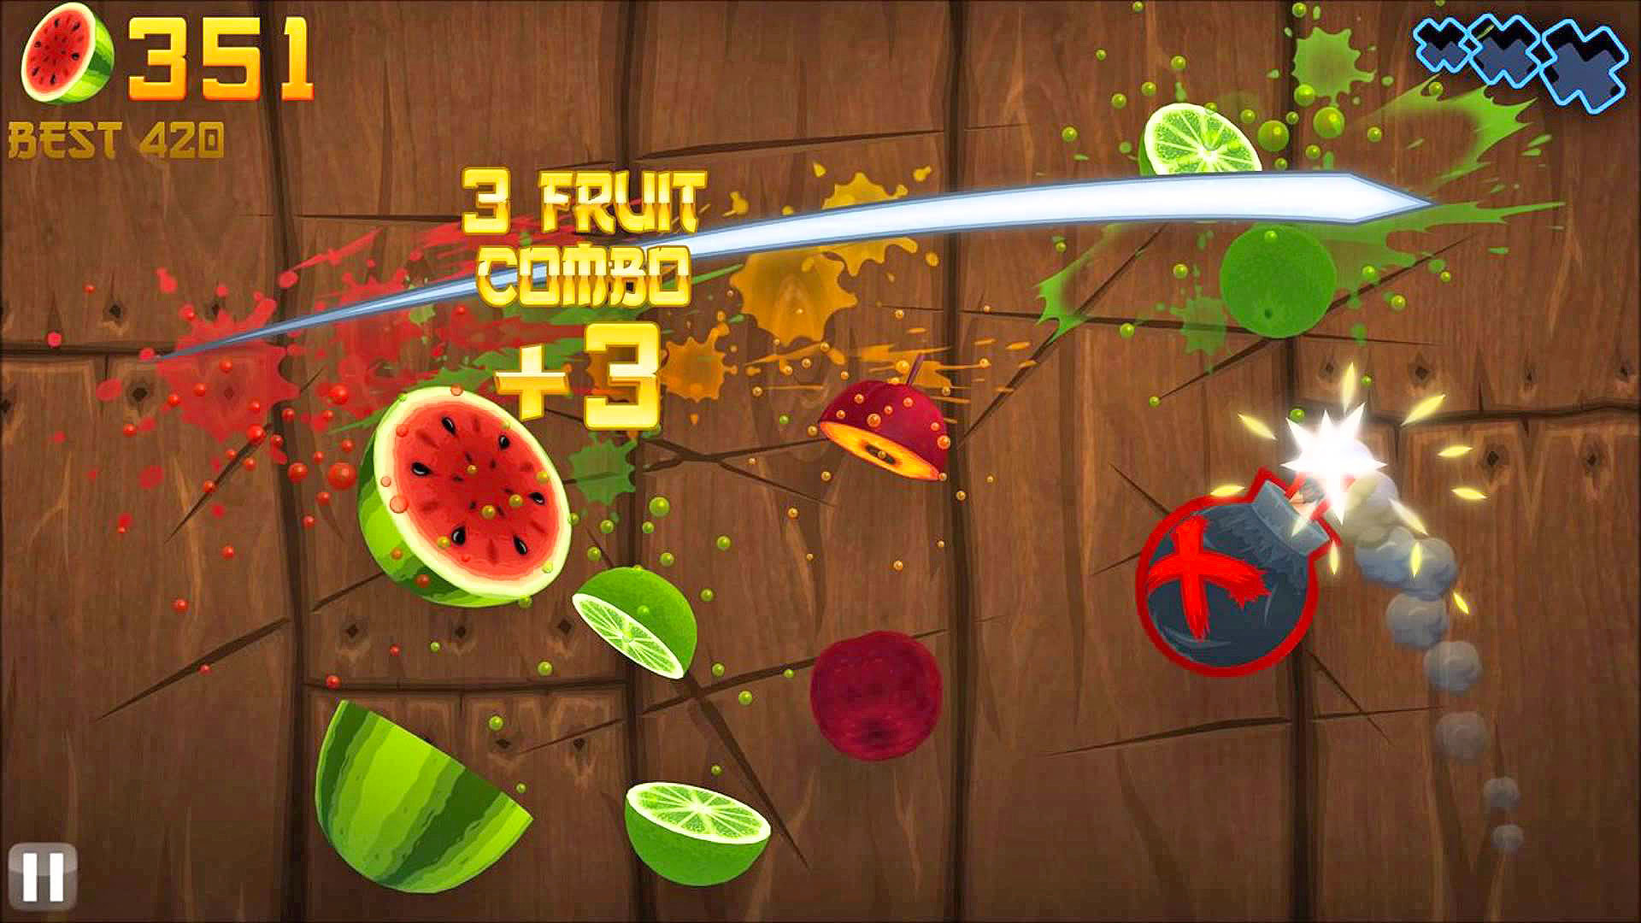](https://o.aolcdn.com/images/dims?quality=85&image_uri=http://o.aolcdn.com/hss/storage/midas/5dcaa329628f2ff2fbd1feda1c1af4a7/203930793/maxresdefault-ed.jpg&client=amp-blogside-v2&signature=fa7c3b053ffc2b1b3dd4907b8bf7ef88982ae3e2)

[[7]](https://o.aolcdn.com/images/dims?quality=85&image_uri=http%3A%2F%2Fo.aolcdn.com%2Fhss%2Fstorage%2Fmidas%2F5dcaa329628f2ff2fbd1feda1c1af4a7%2F203930793%2Fmaxresdefault-ed.jpg&client=amp-blogside-v2&signature=fa7c3b053ffc2b1b3dd4907b8bf7ef88982ae3e2)

Entertainment – Entertainment applications are becoming popular on mobile devices more and more every day. This is because the portability of a mobile device added with the convenience of TV shows and films being on applications on their devices means it

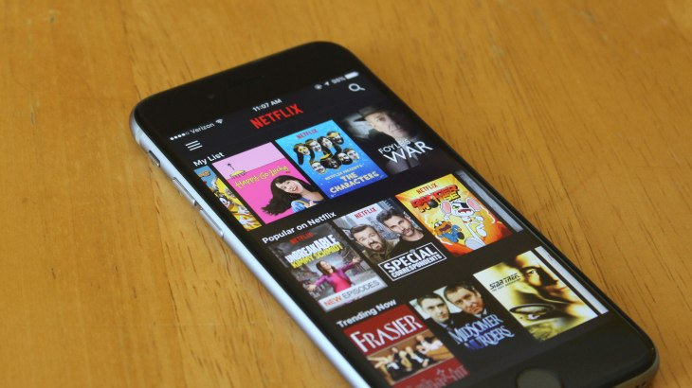[[8]](https://techcrunch.com/wp-content/uploads/2016/05/netflix-ios.jpg?w=730&crop=1)

Widgets – Widgets are mini applications that sit in their designated widget area on a device. Lots of newer widgets come with their applications, or the applications come with widgets. Widgets are useful because they provide small but accurate details that mean that you don’t need to open an application. An example of a widget application is Shortcuts.

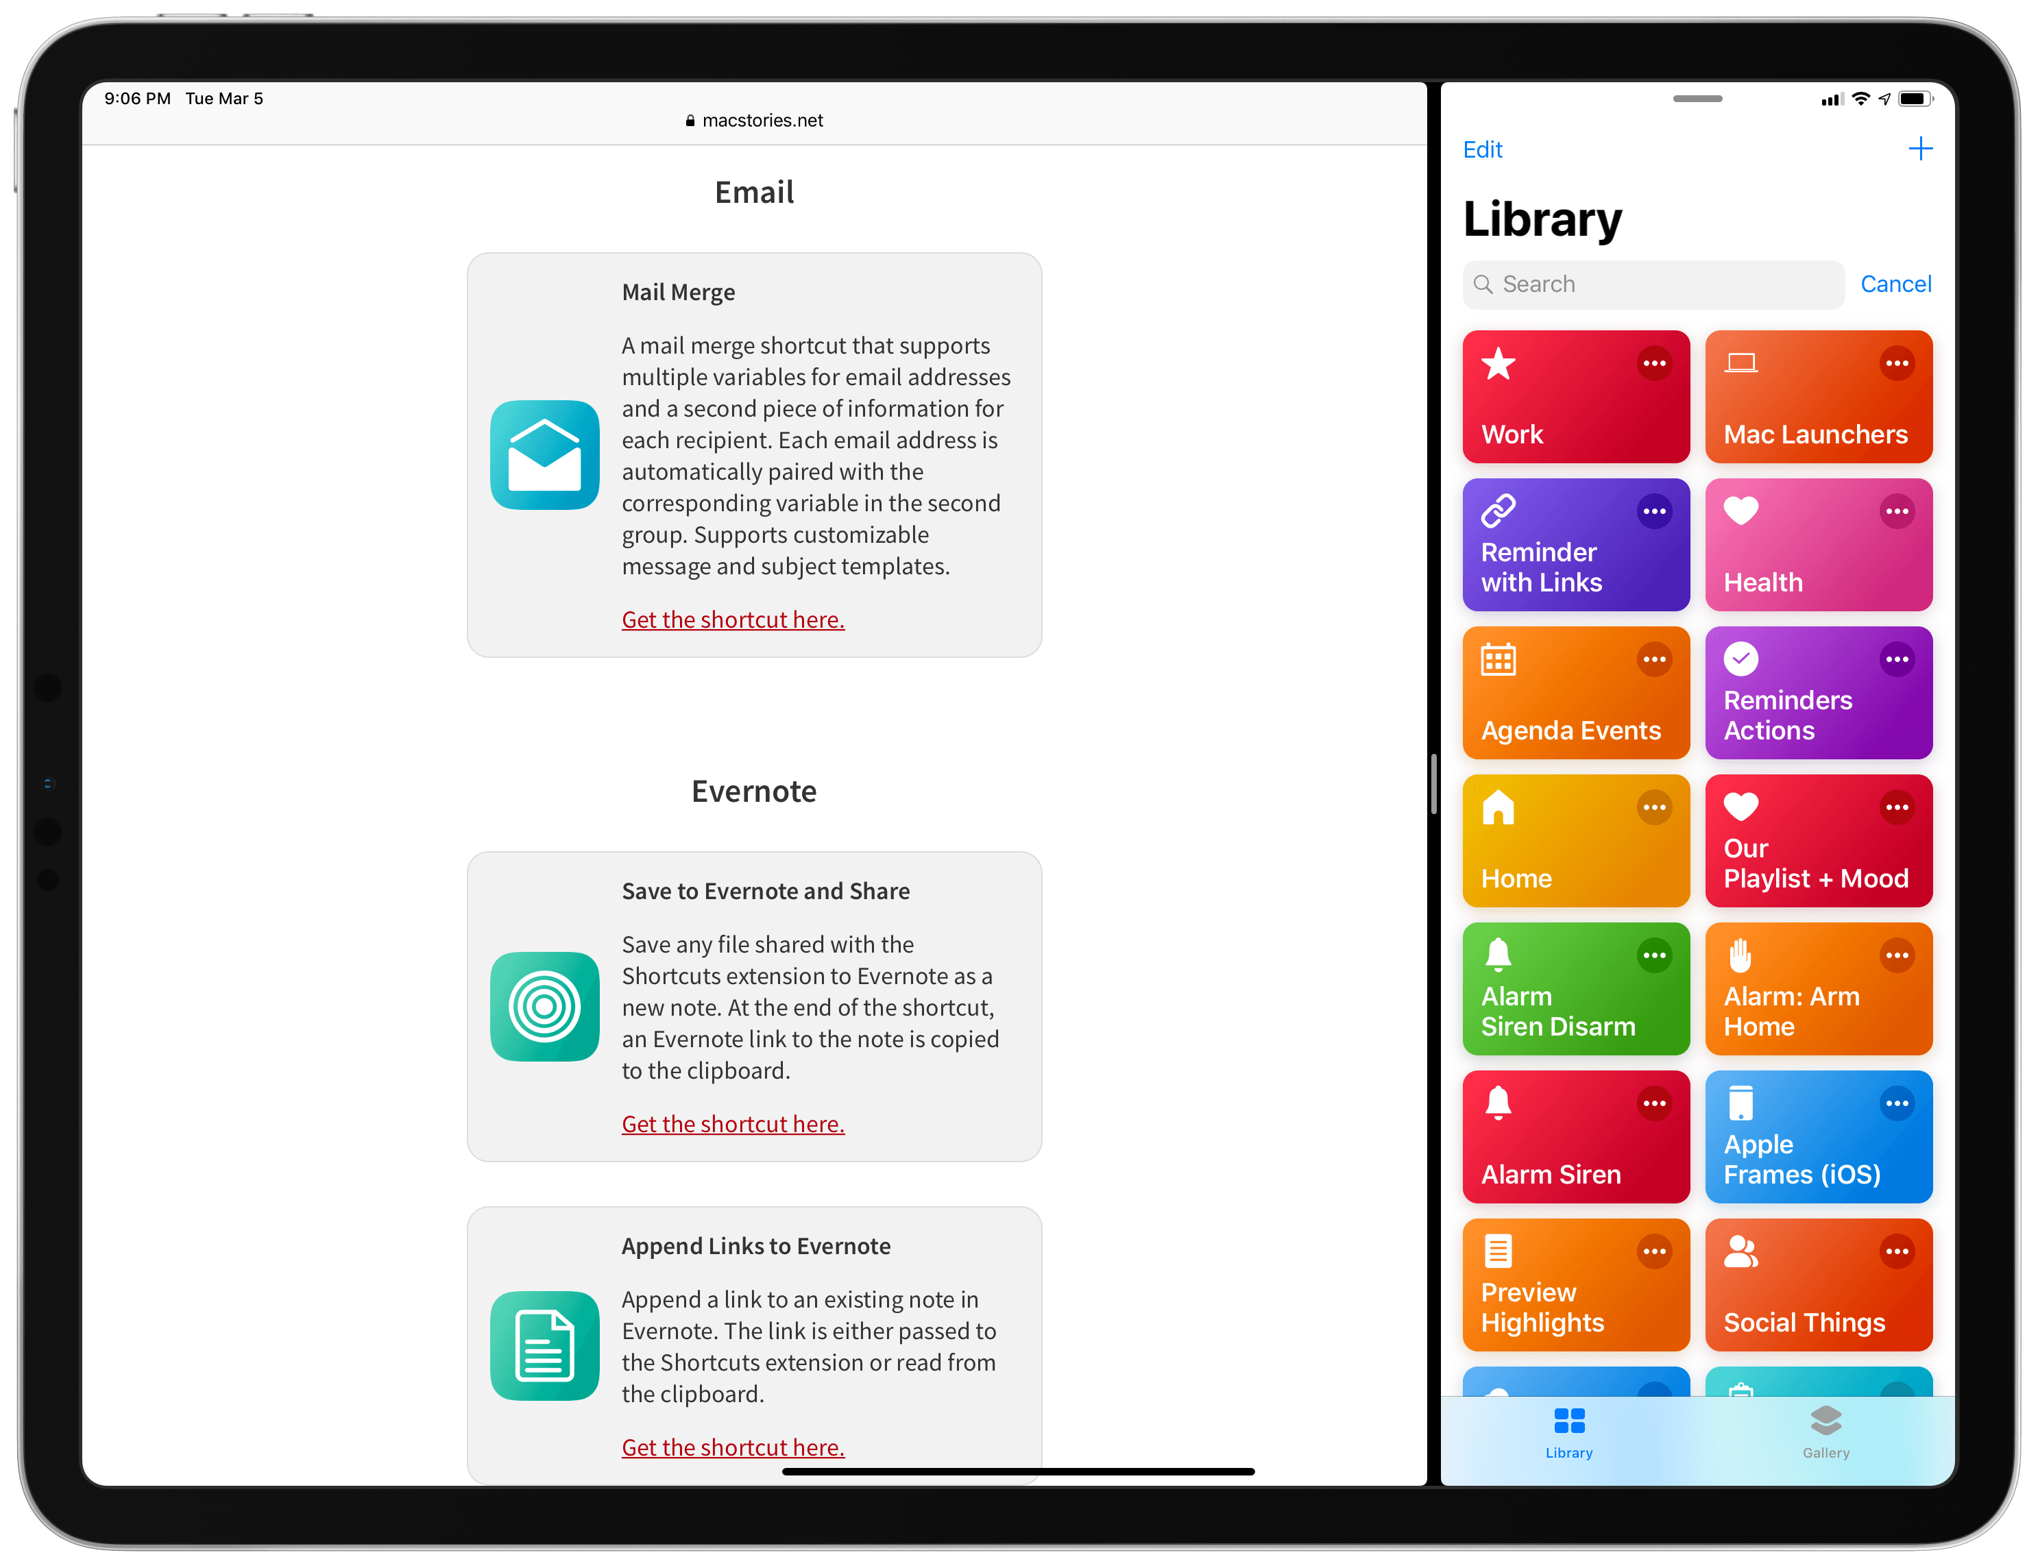[[9]](https://2672686a4cf38e8c2458-2712e00ea34e3076747650c92426bbb5.ssl.cf1.rackcdn.com/2019-03-05-21-08-57.png)

**Developing apps**

There are several differences developing for Apple iOS as opposed Google Android. For Apple’s iOS there are several considerations that need to be put into place in order to develop and application for iOS. Firstly, for iOS, there are several setbacks and limitations that will prevent the speed of an application appearing in the App Store, one of these limitations is the ability to learn Swift, the language used to program applications, Swift is a complicated language. The time it will take to learn and practice Swift will be a major setback for the development of an application.

[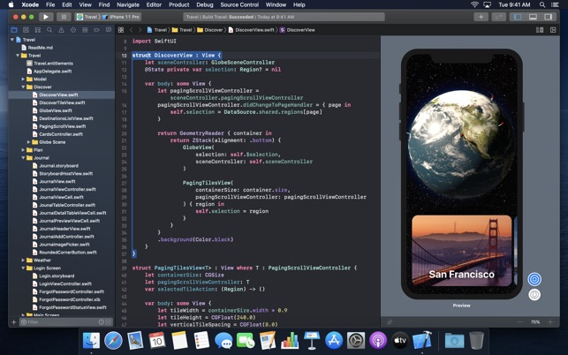[10]](https://is3-ssl.mzstatic.com/image/thumb/Purple113/v4/f6/71/22/f671228b-5f10-5b08-5d47-27a1172486b5/pr_source.png/643x0w.jpg)

Another setback is the time it takes for the application to be verified by Apple and then published on the App Store, however this is minor since 50% of apps are accepted after 24 hours and 90% of apps are verified after 48 hours, but the chance of the application being the final 10% reviewed after 48 hours have passed.

[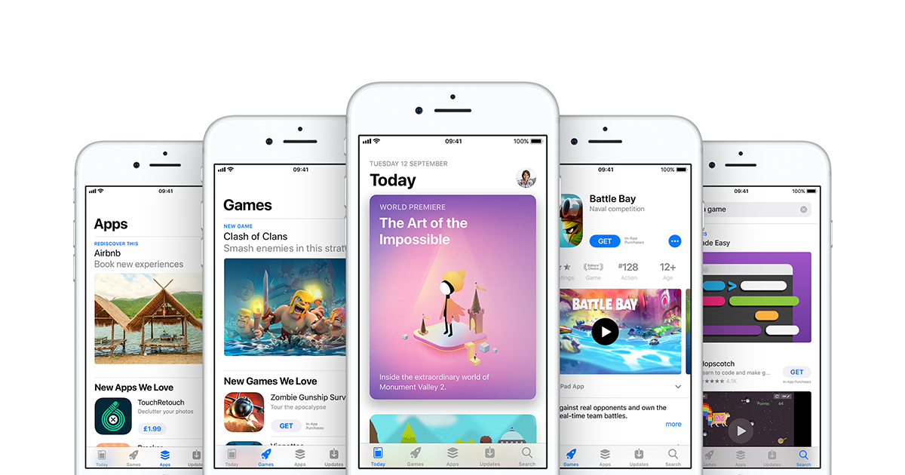[11]](https://www.apple.com/uk/ios/app-store/images/og.png?201909270352)

iOS applications are not allowed much (if any) access to the actual device settings and hardware that is restricted by iOS. This is one of the reasons that ‘Jailbreaking’ is such a common thing for iOS devices. Jailbreaking an iOS device properly means that it can be opened up more and the internals of the device can be edited. Once a device is jailbroken, it has an app called ‘Cydia’ installed. Cydia is an App Store alternative which

[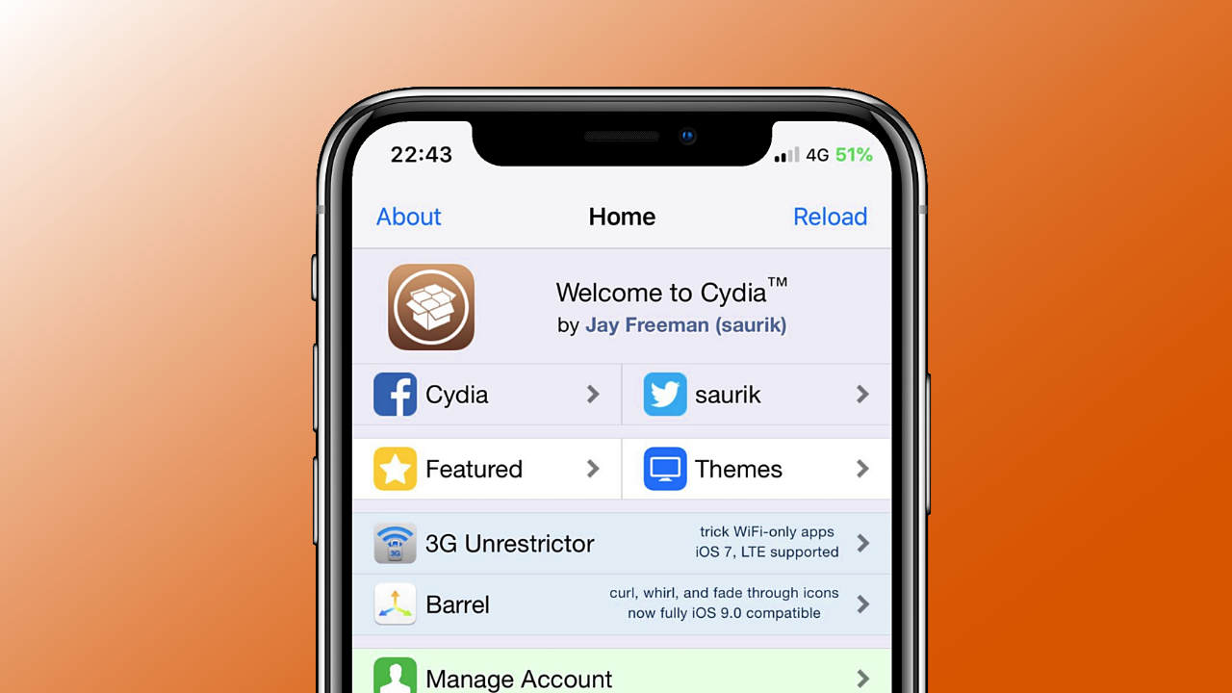[12]](https://cydia-app.com/wp-content/uploads/2020/01/cydia-appstore.png)

There are several differences developing for Google Android as opposed Apple’s iOS. For Google’s Android, it only takes 2 hours for an app to appear on the Google Play Store which means it is 12-24x quicker than for the App Store. This means that there is a much bigger chance that an application will be able to gain a larger audience on the Play Store before an app on the App Store does.

[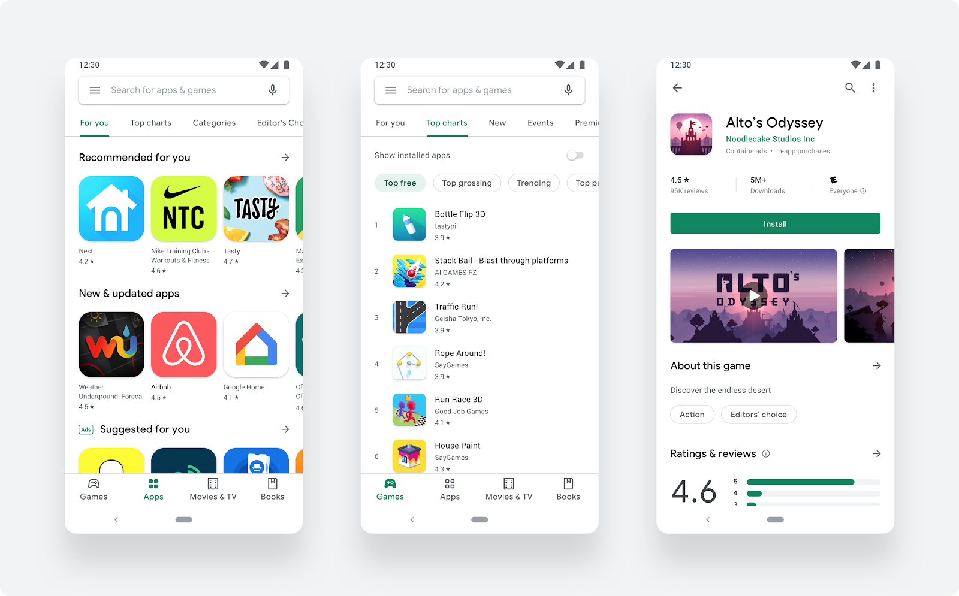[13]](https://1.bp.blogspot.com/-LA3A-hDVlpA/XVxLnkAQ4oI/AAAAAAAALiU/PQOEPx8DqXEbsxi7s2TJRW1P_o-IED2YgCLcBGAs/s1600/page.png)

Android uses Java to program their applications however, it is possible to also use C# and C++ as languages to develop with as well. Java is not a particularly complicated language. Likewise, neither are C# and C++

[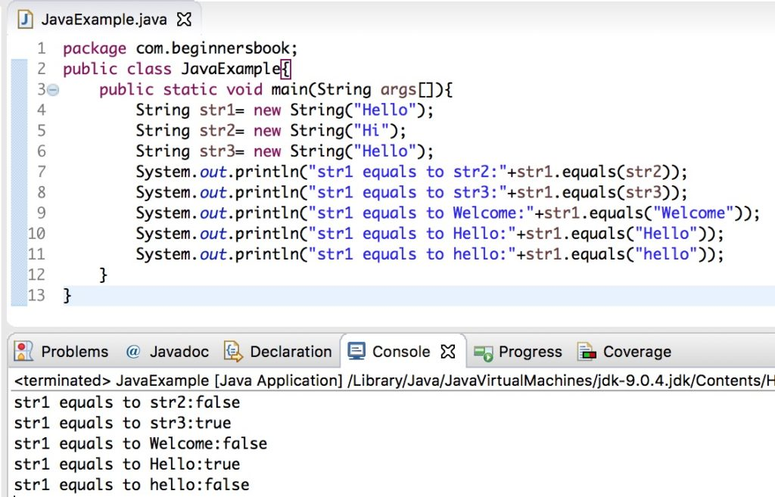[14]](https://beginnersbook.com/wp-content/uploads/2013/12/Java_equals_example-1024x657.jpg)

**Bibliography:**

[1] <https://www.imore.com/sites/imore.com/files/styles/xlarge/public/field/image/2016/09/ios-10-health-activity-1.jpg?itok=kgjNpzfq>

[2] <https://developers.google.com/web/showcase/2016/images/aliexpress/aliexpress_framed.gif>

[3] <https://cdn.vox-cdn.com/thumbor/Dokf2NLzsEAILKfjR51n_P4tC0U=/0x0:2139x1536/1200x800/filters:focal(899x597:1241x939)/cdn.vox-cdn.com/uploads/chorus_image/image/53689365/waze_spotify.0.jpg>

[4] <https://www.extremetech.com/wp-content/uploads/2019/10/maps-generic-640x353.jpg>

[5] <https://i.stack.imgur.com/X86Wz.jpg>

[6] <https://evernote.com/c/assets/homepage/homepage-hero-desktop.png?3044bdd28d311821>

[7] <https://o.aolcdn.com/images/dims?quality=85&image_uri=http%3A%2F%2Fo.aolcdn.com%2Fhss%2Fstorage%2Fmidas%2F5dcaa329628f2ff2fbd1feda1c1af4a7%2F203930793%2Fmaxresdefault-ed.jpg&client=amp-blogside-v2&signature=fa7c3b053ffc2b1b3dd4907b8bf7ef88982ae3e2>

[8] <https://techcrunch.com/wp-content/uploads/2016/05/netflix-ios.jpg?w=730&crop=1>

[9] <https://2672686a4cf38e8c2458-2712e00ea34e3076747650c92426bbb5.ssl.cf1.rackcdn.com/2019-03-05-21-08-57.png>

[10] <https://is3-ssl.mzstatic.com/image/thumb/Purple113/v4/f6/71/22/f671228b-5f10-5b08-5d47-27a1172486b5/pr_source.png/643x0w.jpg>

[11] <https://www.apple.com/uk/ios/app-store/images/og.png?201909270352>

[12] <https://cydia-app.com/wp-content/uploads/2020/01/cydia-appstore.png>

[13] <https://1.bp.blogspot.com/-LA3A-hDVlpA/XVxLnkAQ4oI/AAAAAAAALiU/PQOEPx8DqXEbsxi7s2TJRW1P_o-IED2YgCLcBGAs/s1600/page.png>

[14] <https://beginnersbook.com/wp-content/uploads/2013/12/Java_equals_example-1024x657.jpg>